A
Synopsis
On
“Customer Segmentation & Sales
Performance Analysis”
Submitted By:
- Sahil Narayan Dalavi
- Trupti Baburao Chougale
B.Tech.(Artificial Intelligence and Data Science Engineering.)
Under the Guidance of
Prof. -Dr.S.S.Sarade

Department of Artificial Intelligence and Data Science Engineering.
Ashokrao Mane Group of Institutions, Vathar Tarf Vadgaon,
Dr. Babasaheb Ambedkar Technological University, Lonere

AY- 2026-2027

1.Name of College: Ashokrao Mane Group of Institutions, Vathar Tarf Vadgaon

2.Name of Course: B.Tech. (Artificial Intelligence and Data Science Engineering.)

3.Name of Student: 1) Sahil Narayan Dalavi
2) Trupti Baburao Chougale

4.Date of Registration:
5. Name of Project Guide: Prof. Dr.S.S.Sarade
6. Name of Project: “Customer Segmentation & Sales Performance Analysis”

INDEX

Sr.no. |  | TITLE
1 | Introduction
2 | Relevance
3 | Literature Review
4 | Problem Statement
5 | Objectives
6 | Proposed Work  6.1 Block Diagram  6.2 Working  6.3 Equipment Details
7 | Facilities Required
8 | Reference

1. INTRODUCTION
Customer Segmentation & Sales Performance Analysis is a data analytics project developed using Power BI to analyze customer purchasing behavior, sales trends, and revenue performance. The Analysis helps businesses understand customer preferences, subscription behavior, product category performance, and age-group-based sales insights.
The project converts raw sales data into meaningful visual reports and interactive Analysiss. It enables businesses to make data-driven decisions by identifying profitable customer groups, top-selling categories, and revenue-generating segments.
The Analysis provides visual insights such as:
- Active Customers
- Average Order Value
- Total Revenue
- Revenue by Category
- Sales by Category
- Revenue by Age Group
- Sales by Age Group
- Subscription Status Analysis
The Analysis also allows filtering based on:
- Gender
- Category
- Shipping Type
- Subscription Status
This project demonstrates how Business Intelligence (BI) tools can improve business decision-making through visualization and customer analytics.
The Power BI Analysis uploaded in the project visually presents these analytics and KPIs.

2. RELEVANCE
In today’s competitive business environment, organizations generate large amounts of customer and sales data. Analyzing this data manually is difficult and time-consuming. Therefore, businesses require intelligent Analysis that can transform raw data into useful insights.
This project is highly relevant because it helps businesses:
- Understand customer buying behavior
- Identify profitable customer segments
- Analyze revenue trends
- Improve product marketing strategies
- Increase customer retention
- Support better business decisions
Customer segmentation helps companies target the right customers with suitable products and services. Sales performance analysis enables businesses to identify which categories generate higher revenue and which customer groups contribute most to sales.
The Analysis provides an easy-to-understand graphical representation of data, making business analysis faster and more efficient.

3. LITERATURE REVIEW

1. Business Intelligence Systems
Business Intelligence tools help organizations convert raw data into meaningful insights using Analysiss, reports, and analytics.

2. Customer Segmentation
Customer segmentation divides customers into groups based on purchasing behavior, demographics, and interests to improve marketing strategies.

3. Data Visualization Techniques
Charts, graphs, and KPIs help users quickly understand sales trends and business performance.

4. Sales Analytics
Sales analytics identifies revenue patterns, profitable products, and customer preferences for better business growth.

5. Power BI Applications
Power BI is widely used for creating interactive Analysiss, data transformation, and real-time business reporting.

6. Analysis-Based Decision Making
Modern businesses use Analysiss for strategic planning, forecasting, and operational management.

7. Importance of Customer Analytics
Customer analytics improves customer satisfaction, retention, and personalized marketing strategies.

8. Research Gap
Many systems focus only on sales reports, but fewer systems combine customer segmentation and sales analytics together in one interactive Analysis.

9. Relevance to This Project
This project combines customer segmentation, sales performance analysis, and interactive visualization using Power BI.

4. PROBLEM STATEMENT
1. Difficulty in Analyzing Large Sales Data
Businesses generate huge amounts of sales and customer data that are difficult to analyze manually.
2. Lack of Proper Visualization
Traditional reports are difficult to understand and do not provide quick business insights.
3. Inefficient Customer Analysis
Organizations struggle to identify customer behavior and profitable customer groups.
4. Need for Interactive Business Analysiss
Businesses require dynamic Analysiss for real-time decision-making and performance tracking.
Proposed Solution
Develop a Customer Segmentation & Sales Performance Analysis using Power BI to:
- Analyze customer purchasing behavior
- Monitor revenue and sales trends
- Segment customers based on age and subscription status
- Visualize business insights through interactive charts and KPIs
Goal
To provide a smart and interactive Analysis that improves customer analysis and business decision-making.

5. OBJECTIVES
The main objectives of the project are:

- To develop a Customer Segmentation & Sales Performance Analysis using Power BI.
- To analyze customer purchasing behavior and sales trends.
- To visualize key business metrics such as Total Revenue, Active Customers, and Average Order Value.
- To perform customer segmentation based on age group, gender, and subscription status.
- To analyze category-wise sales and revenue performance.
- To provide interactive filters and visual reports for easy analysis.
- To convert raw sales data into meaningful business insights using data visualization techniques.
- To support data-driven decision-making for improving business performance.
- To identify profitable customer groups and product categories.
- To improve understanding of customer behavior and market trends.

6.PROPOSED WORK
6.1 BLOCK DIAGRAM:-
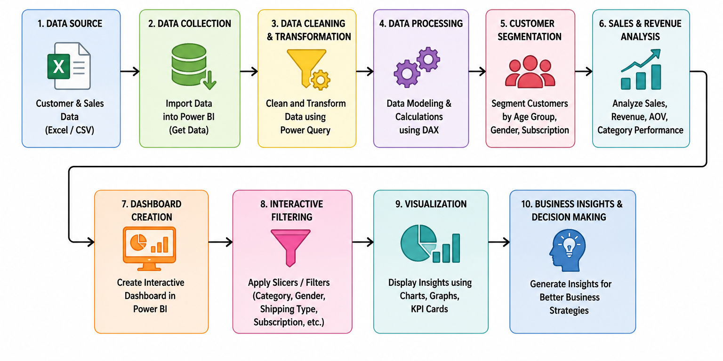

6.2 WORKING: -
- Data Collection:
Customer and sales data are collected from Excel/CSV datasets.
- Data Import:
The dataset is imported into Power BI for analysis and visualization.
- Data Cleaning:
Missing values, duplicate records, and incorrect data are removed using Power Query.
- Data Transformation:
Data is transformed into a proper format by changing data types, creating relationships, and organizing fields.
- Data Processing:
Important calculations such as Total Revenue, Average Order Value, and Active Customers are performed using DAX functions.

- Customer Segmentation:
Customers are grouped based on Age Group, Gender, and Subscription Status.

- Sales Analysis:
Sales and revenue are analyzed category-wise to identify high-performing products.

- Analysis Visualization:
Different charts, KPI cards, graphs, and slicers are created in Power BI to display insights visually.

- Interactive Filtering:
Users can apply filters such as Category, Gender, Shipping Type, and Subscription Status for customized analysis.

- Business Insights Generation:
The Analysis provides meaningful insights that help businesses improve marketing strategies, customer targeting, and decision-making.

6.3 EQUIPMENT DETAILS: -
- Hardware Requirements:

Component | Minimum Requirement
Processor | Intel i3 or equivalent
RAM | 4 GB
Storage | 100 GB HDD
Display | 1366×768 resolution

Software Requirements:
Component | Technology Used
Operating System | Windows 10/11
Tool | Power BI Desktop
Database/File Format | Database/File Format
Programming Support | DAX, Power Query
Visualization Tool | Power BI Charts & KPIs

7.FACILITIES REQUIRED
- Hardware Requirements
Component | Specification | Purpose
Processor | Intel i5 / AMD Ryzen 5 or above | For smooth Analysis processing and analysis
RAM | Minimum 8 GB | For multitasking and efficient Power BI performance
Storage | 256 GB SSD / 500 GB HDD | To store datasets, reports, and project files
Display | 14” or above (1366×768 or higher) | For better Analysis visualization
Internet Connection | Stable Broadband Connection | For data access and cloud services

B. Software Requirements
Software / Tool | Description / Use
Operating System | Windows 10/11
Power BI Desktop | Dashboard creation and visualization
Microsoft Excel | Dataset preparation and management
Power Query | Data cleaning and transformation
DAX | Data calculations and KPI creation
SQL (Optional) | Database query handling
Python (Optional) | Advanced data analysis
Web Browser | Accessing cloud services and Analysiss

C. API and Cloud Services Required
Service | Purpose
Power BI Service | Online analysis publishing and sharing
OneDrive / Google Drive | Cloud storage for datasets and reports
Microsoft Azure (Optional) | Cloud-based analytics and storage
GitHub | Project version control and backup
Kaggle Dataset API (Optional) | Dataset collection and updates
Google Sheets API (Optional) | Real-time data integration

REFERENCE
- Microsoft Power BI Documentation
https://learn.microsoft.com/en-us/power-bi/
- Power Query Documentation
https://learn.microsoft.com/en-us/power-query/
- DAX Function Reference
https://learn.microsoft.com/en-us/dax/
- Han, J., Kamber, M., & Pei, J. Data Mining: Concepts and Techniques. Morgan Kaufmann Publishers.
- Few, S. Information Analysis Design: Displaying Data for At-a-Glance Monitoring.
- Research Papers on Customer Segmentation and Sales Analytics using Business Intelligence Tools.
- Kaggle Dataset Repository
https://www.kaggle.com/datasets
- Tableau & Power BI Data Visualization Research Articles.
- Business Intelligence and Analytics Journals.
- Microsoft Excel Documentation
https://support.microsoft.com/excel/

Conclusion

The Customer Segmentation & Sales Performance Analysis project provides an efficient and interactive solution for analyzing customer behavior and sales performance using Power BI. The Analysis transforms raw sales data into meaningful visual insights through charts, graphs, KPI cards, and filters.
This project helps businesses understand customer purchasing patterns, identify profitable product categories, and analyze revenue trends effectively. Features such as customer segmentation, category-wise sales analysis, and interactive filtering improve business decision-making and overall performance monitoring.
Overall, the project demonstrates the importance of Business Intelligence and Data Visualization in modern business analytics. It provides a user-friendly, scalable, and effective platform for customer analysis and sales performance management.

Place: AMGOI, Vathar
Date:

(GUIDE) (HOD) (Director)
(Prof: S.S.Sarade) (Dr. S.S.Sarade) (Dr. S.R.Chogule)

